**Read Me**

How to run the project?

1. Download zip file of the project from git hub link:

<https://github.com/Manish-K-Arora/simplilearnphase3project>

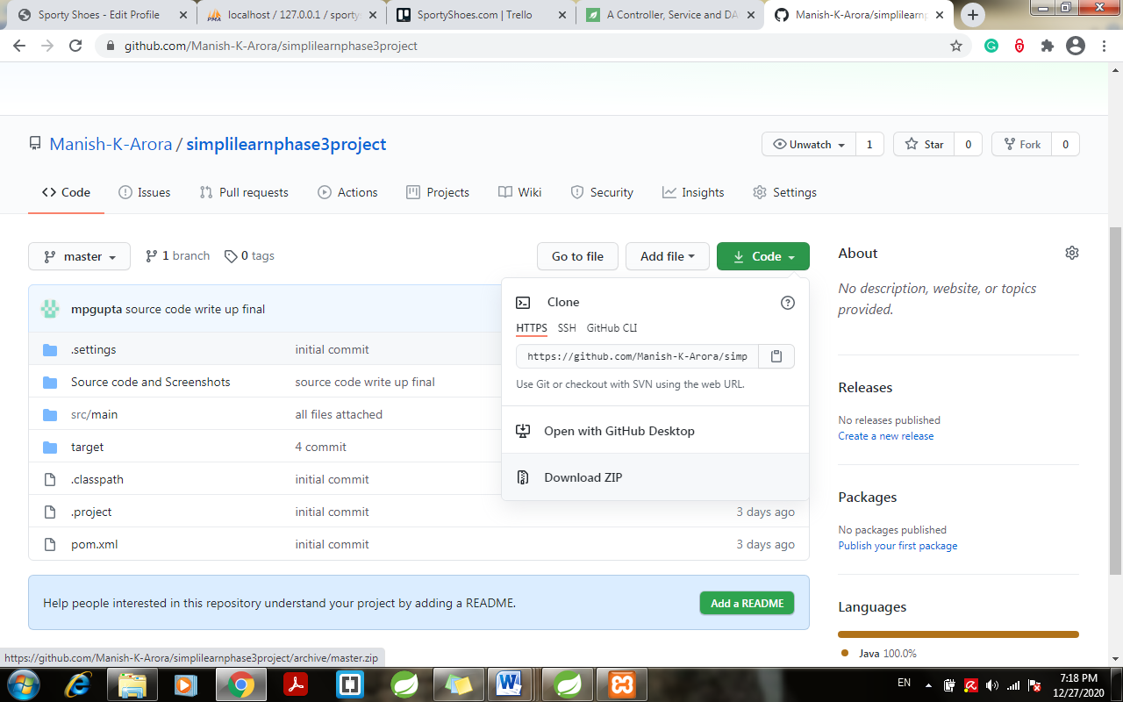

1. Extract the project
2. Open Spring Tool Suite or Eclipse Oxy > click File > Import
3. Import as Existing Maven Project > click next

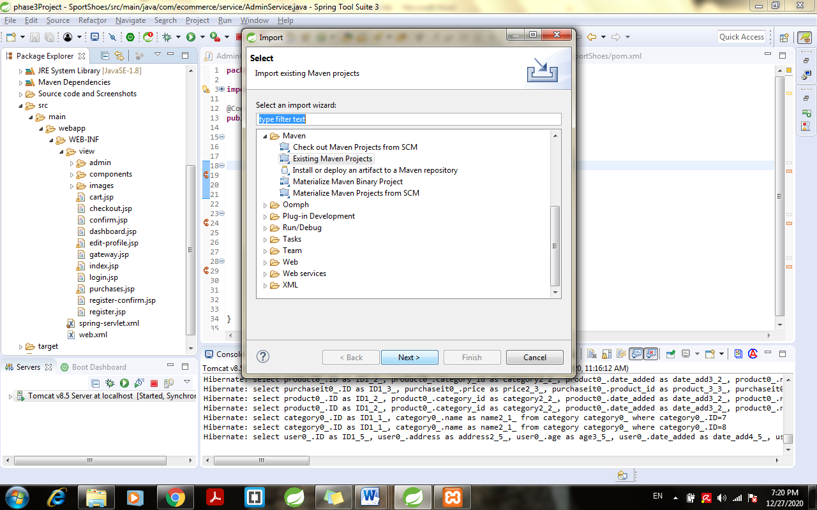

1. Give the directory path where the project extracted in step 2
2. Open Your Xampp Control Panel
3. Start Apache and MySql:

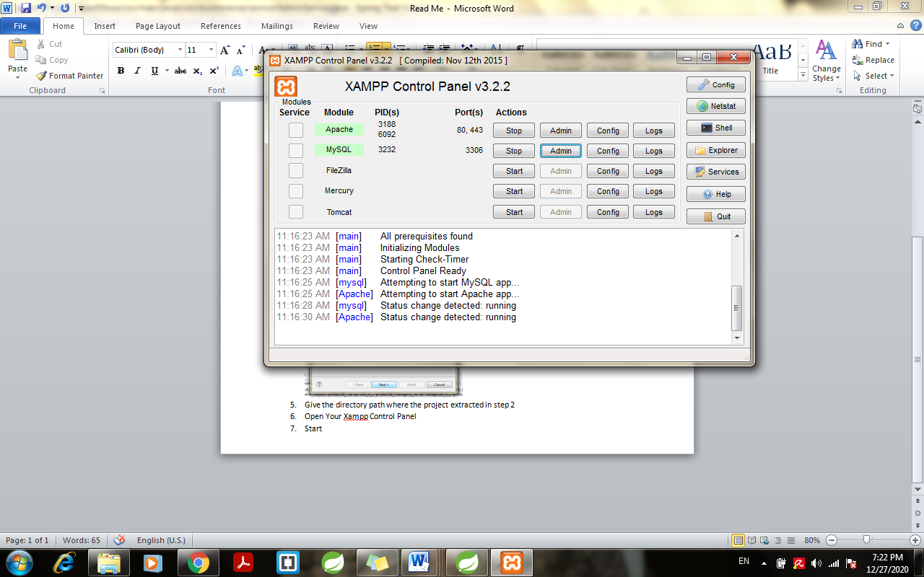

1. Click on Admin > localhost/phpmyadmin page will open
2. Create New Database with name “SportyShoes”
3. Got to the extracted Project > Right Click > Run as > Run on Server:

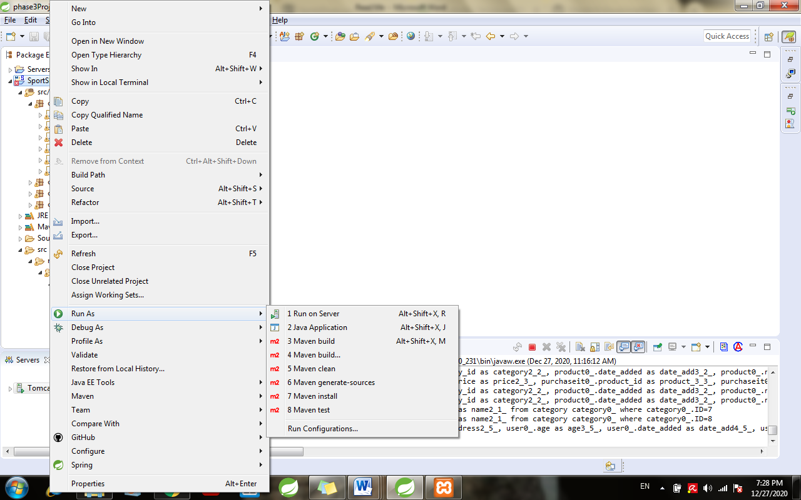

1. Select Tomcat Server > Finish:

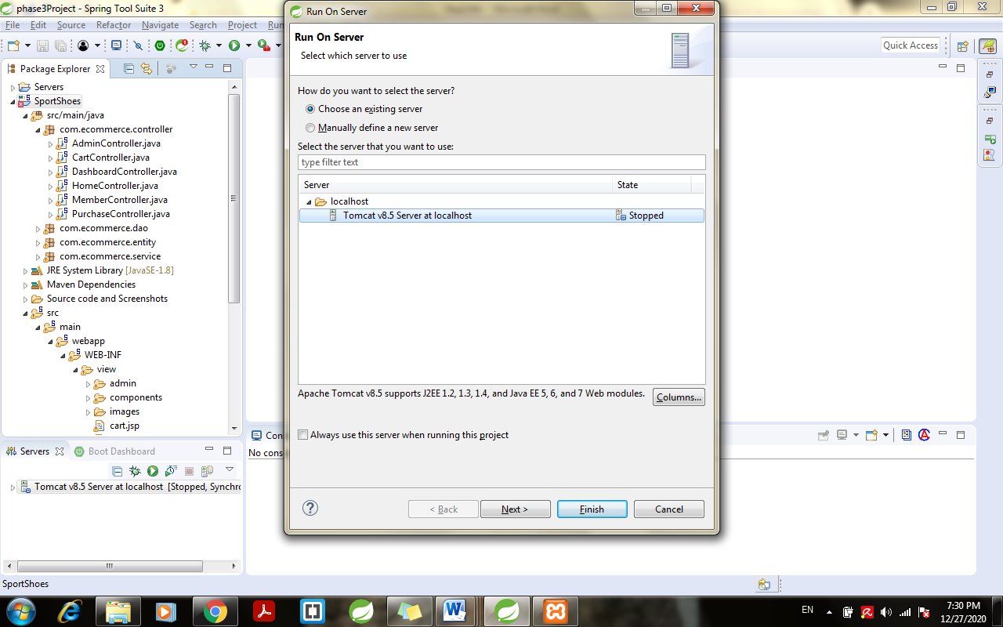

1. Open created Database “sportyshoes ” > tables when first run on server.
2. Open Table “admin” enter username and password of your choice:

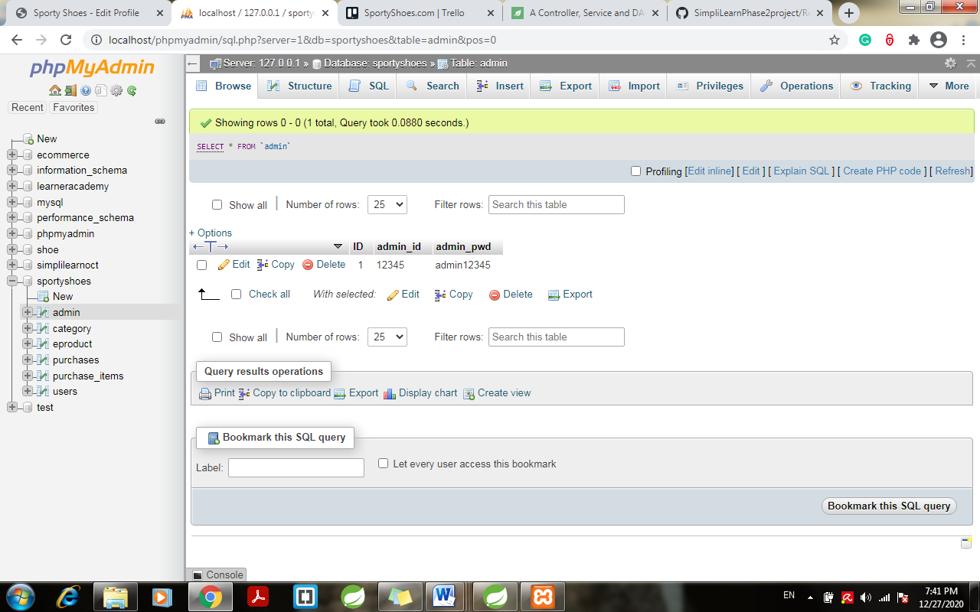

1. Open browser > enter url:

<http://localhost:8082/SportShoes>

1. Click on admin login and enter the username and password entered in admin table.
2. Detailed expanded view for all the classes:

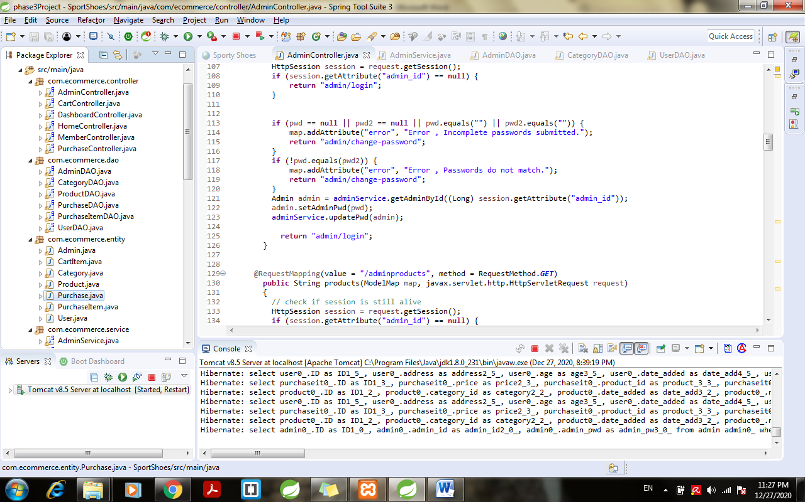

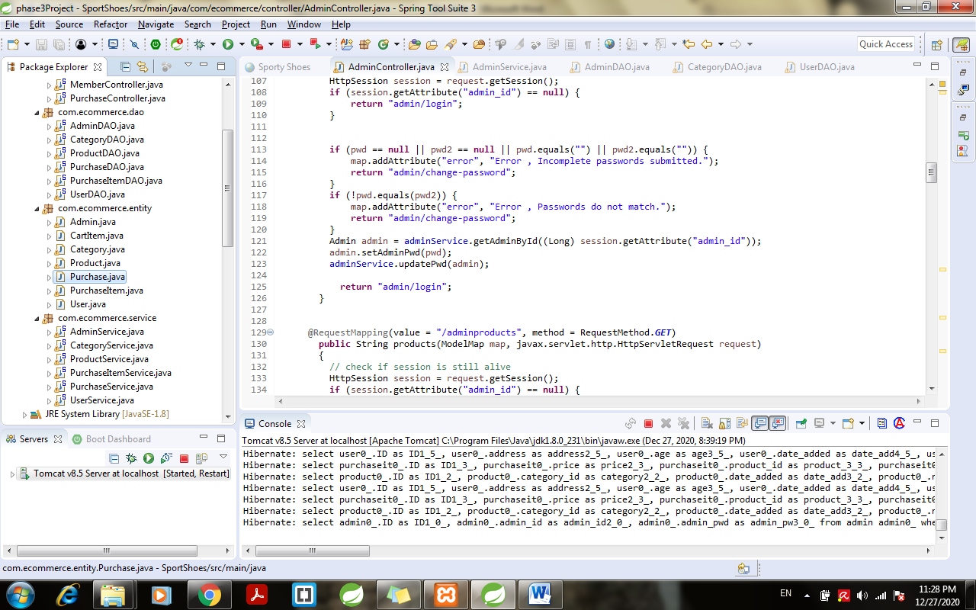

1. Detailed overview of jar used:

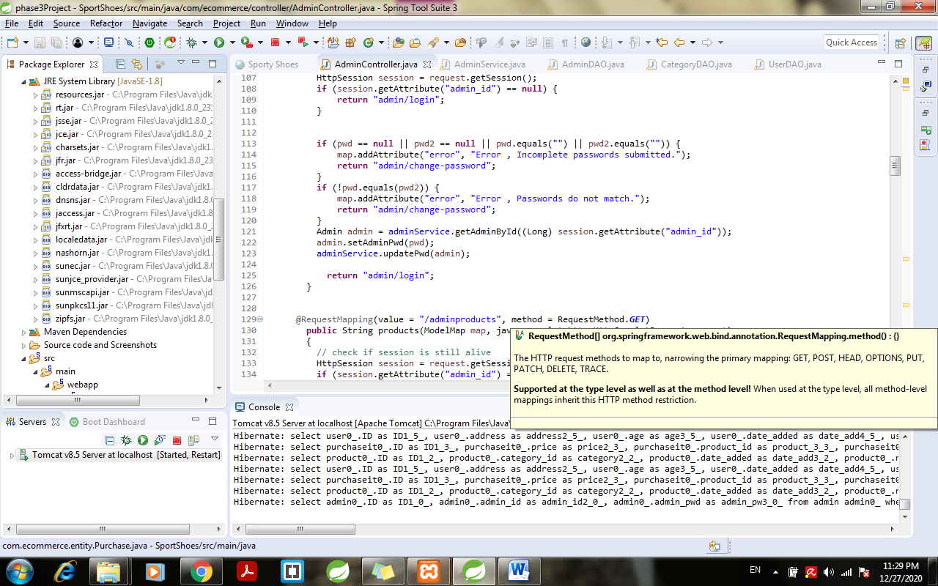

1. Maven jar used:

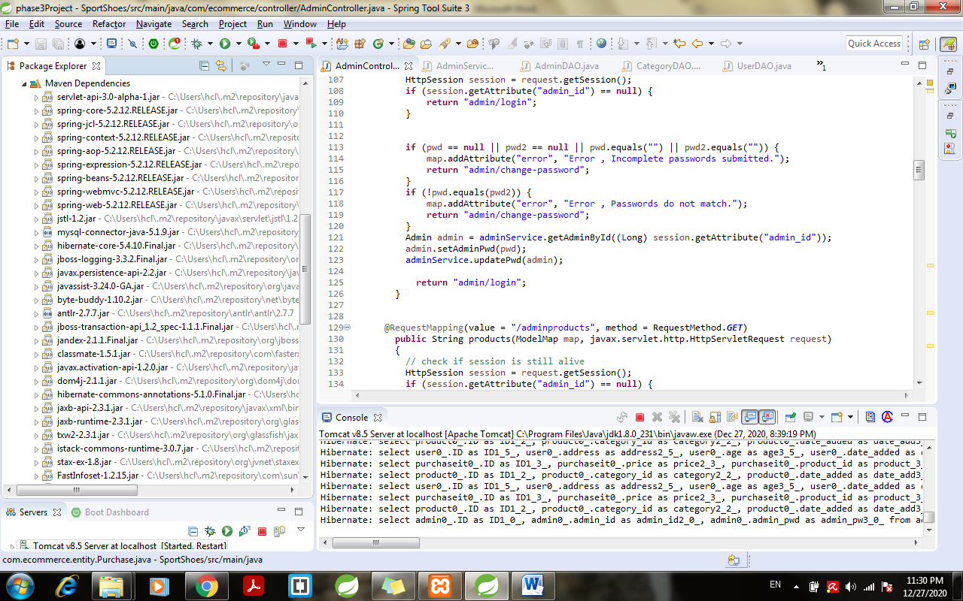

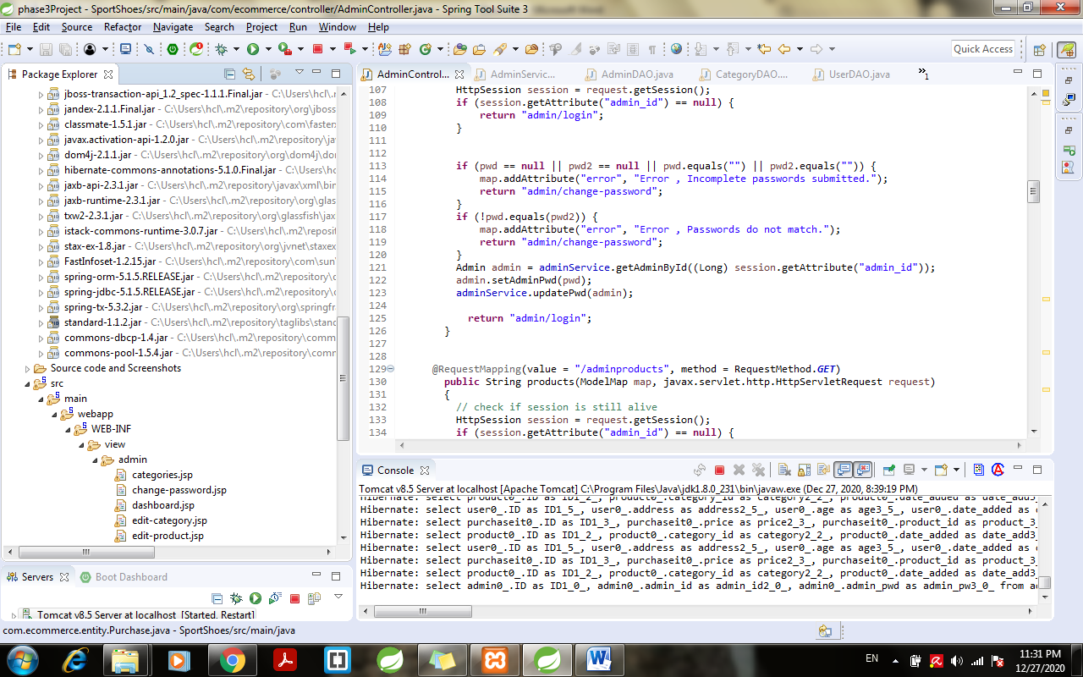

1. JSP files:

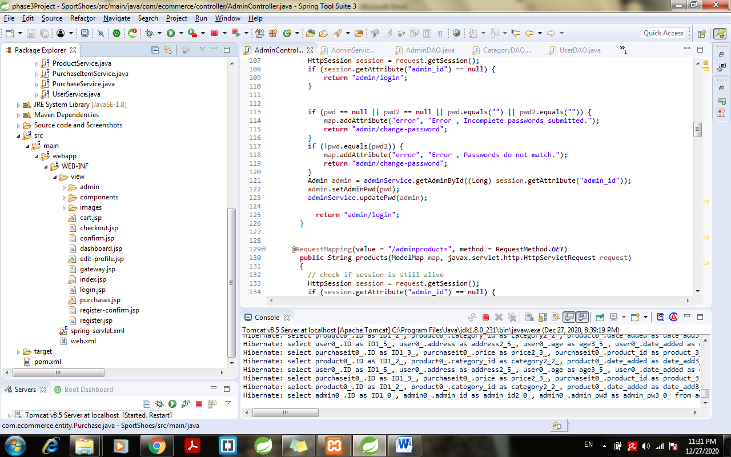

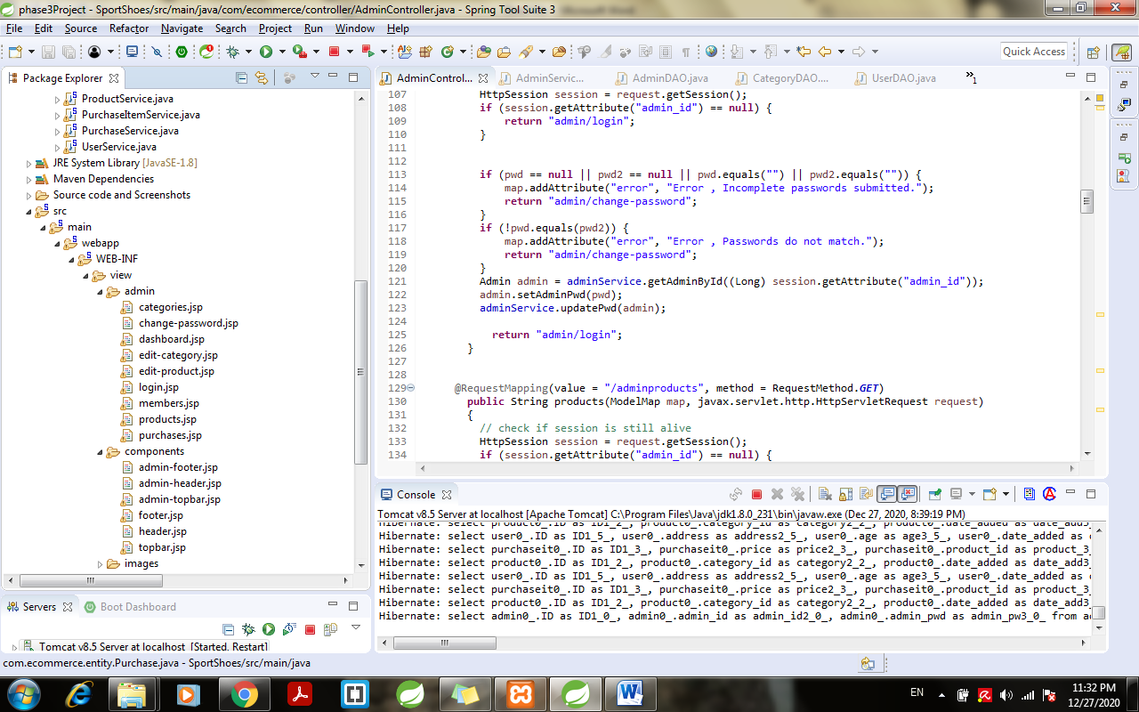

1. XML files:

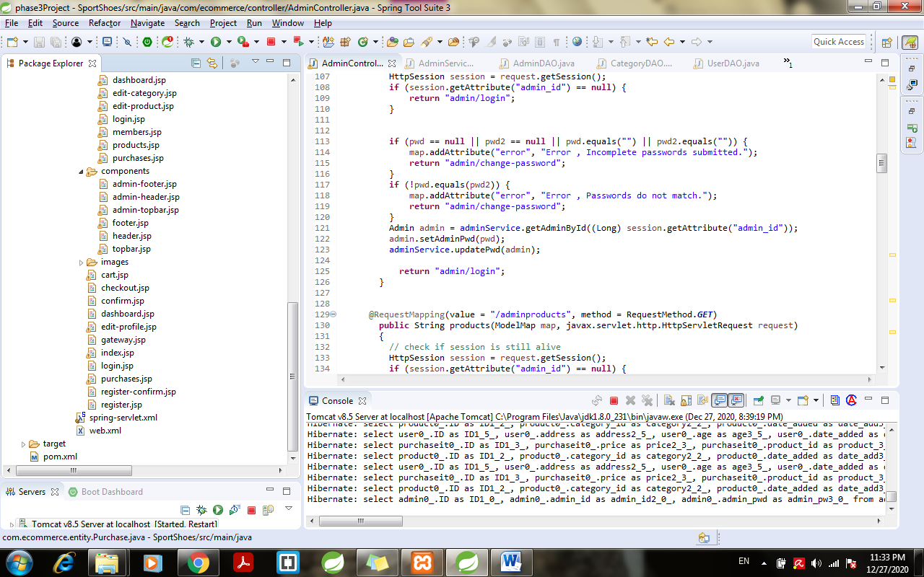

1. Detailed Report found in “Project Report Phase 3”